Part 1: Describe one trend in a single thematic area (Financial market)
The Distributed Ledger Technology particularly caught my attention in relation to the disruptive potential in countless field. One of the applications that most interests me, it’s the Tokenization, which is the representation of ownership of physical assets in a digital world such as the blockchain.
This representation is done by creating a derivative, it’s a type of financial contract whose value is defined by an underlying asset or groups of assets. In the last two years, the development of the DeFi ecosystem has seen also the inclusion of different decentralized derivative exchanges, such as Synthetix and dYdX. Synthetix is a protocol which supports synthetic assets (Synths) on the Ethereum blockchain.
Synthetic assets are tokenized derivatives, they track the value of an underlying assets and offer the exposure to them without the need to actually hold them. They essentially allow investors to tokenize and trade with anything. With this protocols investors can easily trade anything on the blockchain. Unlike traditional trading, which takes place on centralised exchanges, all synthetic asset trades take place on the blockchain.This guarantees traders both their anonymity, and their security.
An example of Synths is sXAU (synthetic gold), the value of sXAU follow the price movements of gold.
There are also the counterparts, the Inverse Synthetic Asset, a derivative which tracks the inverse prime performance of an asset. A perfect example is iBTC (inverse Bitcoin).
Synthetic assets are so unique because they allowed users to be exposed to any real asset in a completely free and frictionless way, there’s the possibility to switch any Synths at any moment, passing from Synthetic Gold to Synthetic Silver just with a couple of clicks, an operation that would have required a big amount of paper and time in the traditional financial system.
The entire decentralized derivatives ecosystem (2022) has a total value locked of $2,24 billion. If we think that the traditional derivatives markets are estimated to involve up to $1 quadrillion, we realize that the space of growth of this decentralized sector is practically endless. It is also important not to forget that this type of process can include types of assets that can’t be included in the traditional derivatives market, such as estates, lands and artworks. Now it is easier to understand how much this technology is revolutionizing the way we trade assets.

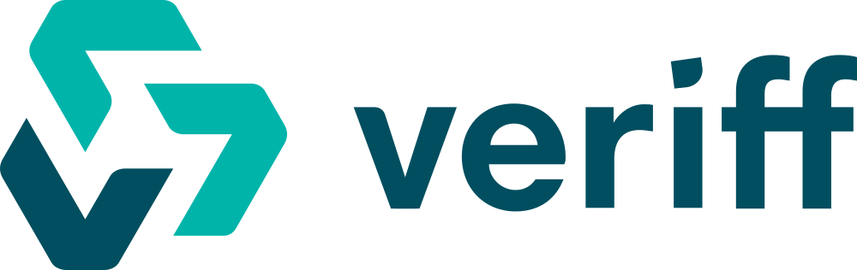

2nd Part
I chose to analyze the company Veriff because I'm very interested in the KYC process and how important the data of users of certain platforms are for regulators.
Veriff, an Estonian company, it’s considered one of the most prominent fintech company in Europe. It’s positioned in a market that has always existed as the market for identity certification and verification. The services that the company offers are the result of innovation and new technologies, which allow document and biometric verification almost immediately. Satisfying already existing customers and markets with new products and technology allows Veriff to be evaluated through closer-in analysis.
That said, Veriff is positioned in the identity verification market. it is a very growing market, especially in recent years where the development of trading platforms and centralized crypto exchanges has required the development of increasingly efficient and secure KYC processes. One of the features that differentiate Veriff the most from other competitors is the user-friendly platform used by customers in order to manage the ID verification of their users, all this is combined with an instant verification (6 seconds) and an extremely high success rate (95%).
Berbix and Trulioo can be considered among Veriff's most direct competitors, with very similar product offerings but with slightly different interfaces and offerings. The main differences can be seen in the field of presentation and marketing of their products and services, which place Trulioo among the best in the industry in terms of customer-oriented communication, but at the same time it rewards Veriff for one of the clearest interfaces in the market. Unfortunately, all companies within this market are still private and therefore a quantitative analysis based on revenues and other financial data is not possible.
The instant verification feature together with the widespread products offering is going to secure to Veriff the competitive advantage in the foreseeable future.
 | Veriff | Berbix | Trulioo
Overview and profile | Customers' identity verification system that is able to adapt itself to the feautures of every business | Customers’ identity verification platform. | Global Online Identity Verification Service
Competitive advantage | Instant conversione service 6s alongside great user conversion time | Simple implementation with an out-of-the-box API library, for pc and mobile set ups. | Biggest digital identity marketplace, backed by important banks such as Goldman Sachs, Santander and CitiBank and other important companies such as American Express
Target Market | They are targeting companies among different industries such as other fintech companies (trading platforms, mobility services) | they are targeting e-commerce and micromobility companies | Their target is from Fortune 500s to small size businesses
Market share | Private company, no data available | Private company and so I found no info about the market size and market share. | Private company and so I found no info about the market size and market share.
Market strategies | Website as the main communication tool, webinars and case studies are available to "educate" the customer about the need of a good identity verification model. | Direct and clean website product oriented | Website and good communication towards inclusion and sustainability
Products and services | Biometric analysis, document verification, fingerprinting device, barcode scanning | Biometric analysis, document verification. | Biometric analysis, document verification, business verification, pay-as-you-go.
Pricing and Costs | Starter plan divided into 3 plans such as "Premium"($2,05 per tx),"Plus"($1,89 per tx) and "Essential"($1,49 per tx). Customizable Enterprise plan for customers wiith special needs. (no cost available | "starter" ($0,99 per transactions and $0,50 per face scan). The "enterprise" pack is totally customizable in order to offer the most suitale service for customers. | "free trial", "growth" and "entrprise" offering from simple to more complex solutions. (no costs available on the website)
Distribution Channels | Ready to go verification service for "starter plan" directly on the website. Consultancy service bookable for customized service through the website. | Deployment of proof of concept and consultative setup process direct on the website | Consultancy service bookable through the website for each type of products

